RUN

PART1 …

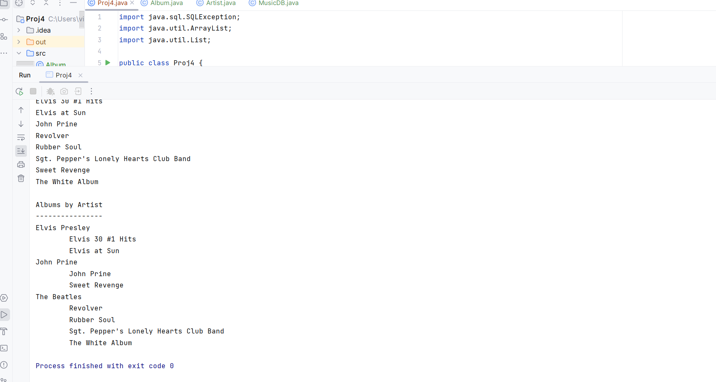

PART 2